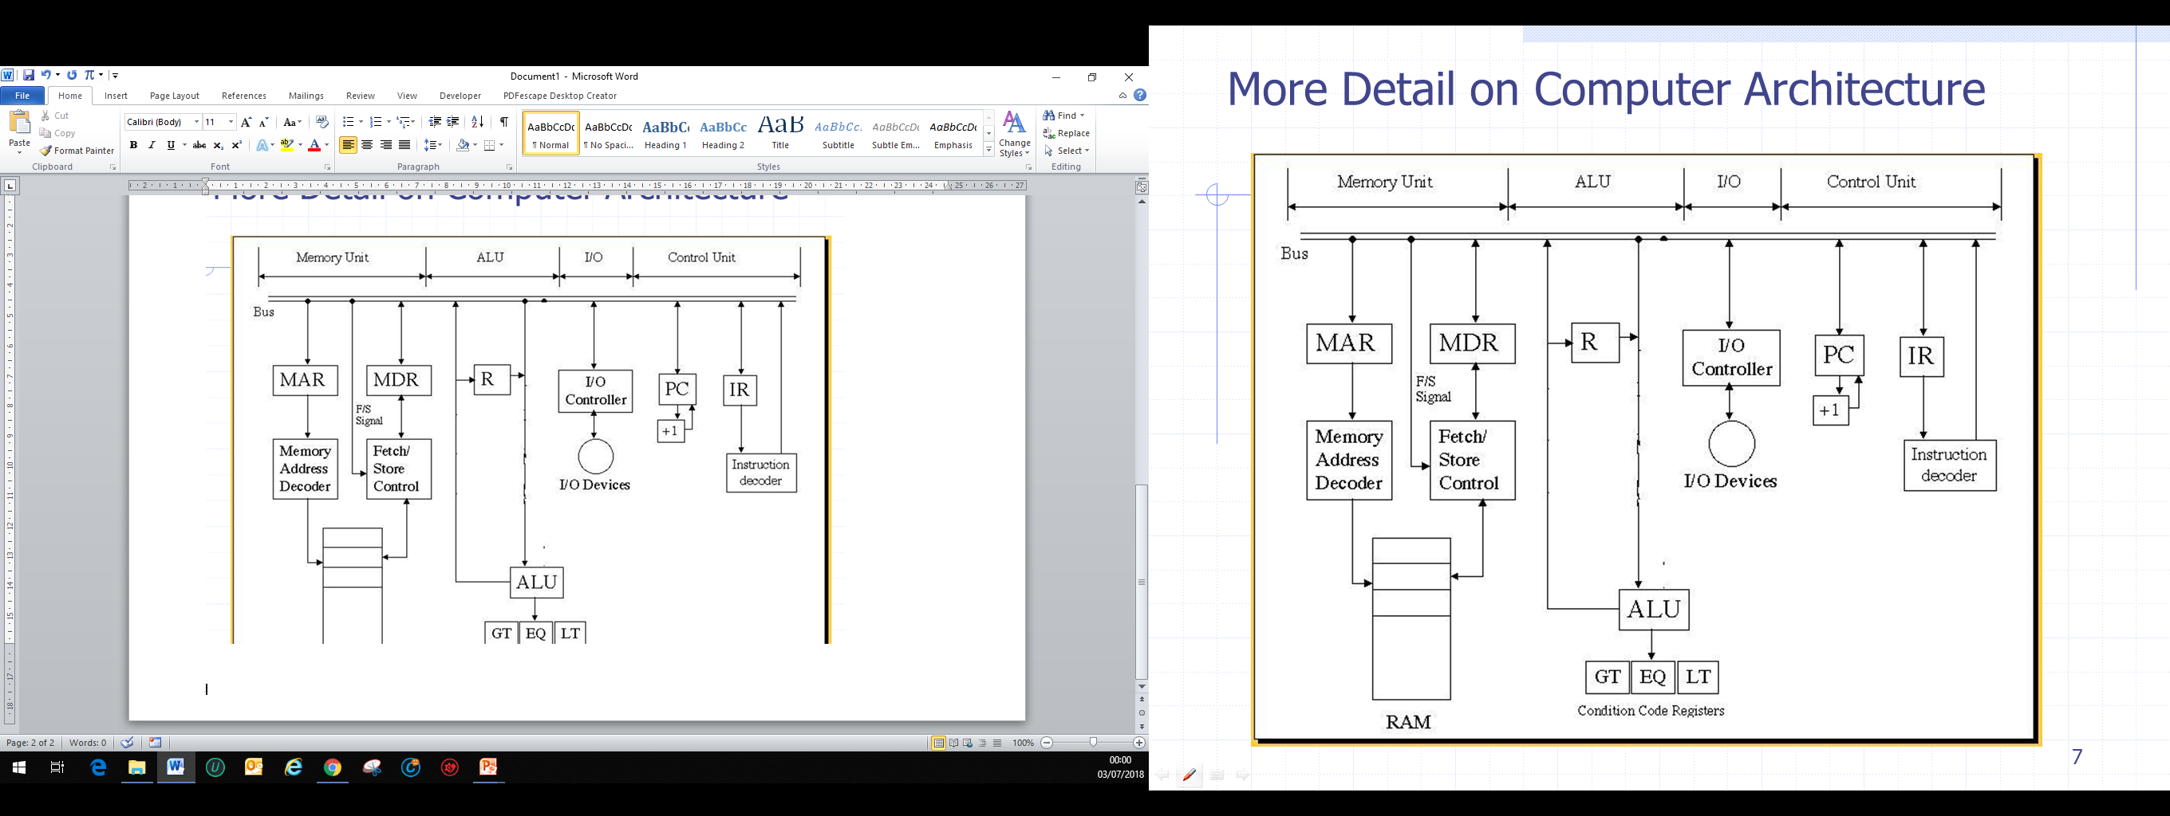

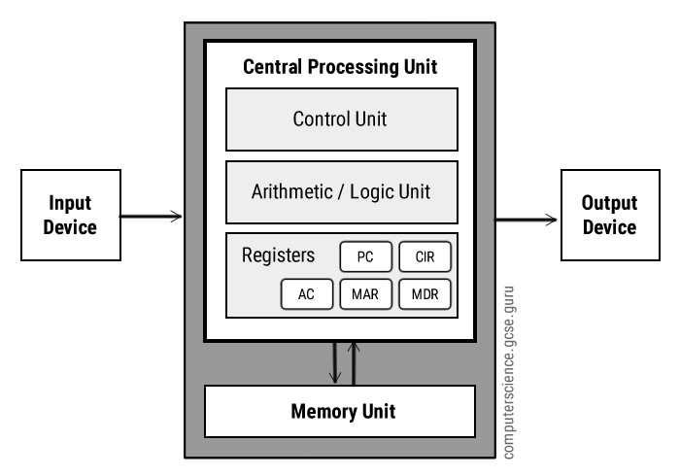

|  |  |  |
| --- | --- | --- |
| MAR |  |  |
| MDR |  |  |
| AC |  |  |
| PC |  |  |
| CIR |  |  |